

**JOMO KENYATTA UNIVERSITY OF AGRICULTURE AND TECHNOLOGY**

**TITLE: GROOMING SYSTEM**

**BY:**

**NAME: MARY NDUNGWA MUTISO**

**REG NO: SCT221-C004-0358/2016**

**COURSE: BSC. IT**

**SUPERVISOR:**

**JUDY GATERI**

**THIS PROJECT HAS BEEN SUBMITTED IN PARTIAL FULFILLMENT OF THE REQUIREMENTS FOR THE AWARD OF THE DEGREE OF BACHELOR OF SCIENCE IN INFORMATION TECHNOLOGY**

**AUGUST 2022**

# DECLARATION

I hereby declare that this project report is based on my original work except for citations and quotations which have been duly acknowledged. I also declare that it’s not been previously and concurrently submitted for any other degree or award at Jomo Kenyatta of Agriculture and Technology.

**NAME:** MARY NDUNGWA MUTISO

**REG NO**: SCT221-C004-0358/2016

……………………………………… ……………………………………….

Signature  Date

# SUPERVISOR

I hereby certify that this is a report for the project undertaken by the above-named student under my supervision and that it has been submitted to Jomo Kenyatta University of Agriculture and Technology with my approval.

**LECTURER:** JUDY GATERI

**DEPARTMENT:** PURE AND APPLIED SCIENCES

……………………………………… ……………………………………….

Signature Date

# ACKNOWLEDGEMENT

I thank The Almighty God for giving me the ability to start of this project to this point.

I thank my family for the support and help during this project in all aspects.

I thank my supervisor, Judy Gateri for helping me understanding the project and offered knowledge and wisdom.

Finally, I thank all my classmates and friends for being very supportive in guiding and assisting me on many aspects of the project.

Contents

[DECLARATION 2](#_Toc113856628)

[SUPERVISOR 3](#_Toc113856629)

[ACKNOWLEDGEMENT 4](#_Toc113856630)

[CHAPTER 1: INTRODUCTION 7](#_Toc113856631)

[1.0 INTRODUCTION 7](#_Toc113856632)

[1.1 PROBLEM DEFINITION 9](#_Toc113856633)

[1.2 OBJECTIVES 10](#_Toc113856634)

[1.2.1 General Objectives 10](#_Toc113856635)

[1.2.2 Specific objectives 10](#_Toc113856636)

[1.3 RESEARCH QUESTIONS 10](#_Toc113856637)

[1.4 JUSTIFICATION 10](#_Toc113856638)

[1.5 LIMITATIONS 11](#_Toc113856639)

[1.6 BUDGET AND SCHEDULE 12](#_Toc113856640)

[1.6.1 ESTIMATED BUDGET 13](#_Toc113856641)

[1.7 PROJECT SCHEDULE 13](#_Toc113856642)

[CHAPTER TWO: LITERATURE REVIEW 14](#_Toc113856643)

[**2.0 Introduction** 14](#_Toc113856644)

[2.1 RELATED STUDIES 15](#_Toc113856645)

[2.1.1 What to Consider when Deciding on the Right Salon Software for Your Salon or Spa 15](#_Toc113856646)

[2.1.2 Supported Countries 15](#_Toc113856647)

[2.1.3 Flexibility vs. Simplicity 16](#_Toc113856648)

[2.1.4 Integrations 16](#_Toc113856649)

[2.1.5 Design 16](#_Toc113856650)

[2.1.6 Price 17](#_Toc113856651)

[2.1.7 Features & Functionality 17](#_Toc113856652)

[2.2 SYNTHESIS OF THE ART 17](#_Toc113856653)

[2.3 GAPS BRIDGED BY THE STUDY 18](#_Toc113856654)

[2.4 HISTORY 18](#_Toc113856655)

[2.5 Advantages of Grooming System 20](#_Toc113856656)

[2.5. 1. Business Automation 20](#_Toc113856657)

[2.5.2. Automatic Creation of a Centralized Database 21](#_Toc113856658)

[2.5.3. Business Mobility 21](#_Toc113856659)

[2.5.4. Cash Management 22](#_Toc113856660)

[2.5.5. Inventory Management 22](#_Toc113856661)

[2.5.6. Business Personalization 23](#_Toc113856662)

[2.5.7. A Great Help in Online Business Marketing Activities 23](#_Toc113856663)

[2.5.8. Automatic Creation of Discounts & Locality Benefits 23](#_Toc113856664)

[2.5.9. Employee Management 24](#_Toc113856665)

[2.6 Existing systems 24](#_Toc113856666)

[2.6.1 Vagaro Online Booking 24](#_Toc113856667)

[2.6.2 Fresha Online Booking 25](#_Toc113856668)

[2.6.3 Mangomint Online Booking 26](#_Toc113856669)

[2.6.4 GlossGenius Online Booking 29](#_Toc113856670)

[2.6.5 Salon Appointment Book 29](#_Toc113856671)

[2.6.6 Vagaro Calendar 30](#_Toc113856672)

[2.6.8 Mangomint Calendar 31](#_Toc113856673)

[2.6.9 GlossGenius Calendar 32](#_Toc113856674)

[2.7 REFERENCES 34](#_Toc113856675)

[CHAPTER 3: METHODOLOGY 36](#_Toc113856676)

[3.0 RESEARCH METHODOLOGY AND DATA GATHERING 36](#_Toc113856677)

[• Review of existing systems 36](#_Toc113856678)

[• Online reviews by other sites 37](#_Toc113856679)

[3.1 SYSTEM DEVELOPMENT METHODOLOGY 37](#_Toc113856680)

[3.2 SYSTEM ANALYSIS 38](#_Toc113856681)

[3.2.1 INTRODUCTION 38](#_Toc113856682)

[3.2.2 FEASIBILITY STUDY 38](#_Toc113856683)

[3.3 Data analysis 40](#_Toc113856684)

[3.3.1 Requirement Specifications 40](#_Toc113856685)

[3.3.2 Functional requirements 40](#_Toc113856686)

[3.3.3 Non-Functional Requirements 41](#_Toc113856687)

[3.3.4 System analysis models 41](#_Toc113856688)

[CHAPTER 4: SYSTEM DESIGN 46](#_Toc113856689)

[4.0 INTRODUCTION 46](#_Toc113856690)

[4.1 THE CONCEPTUAL MODEL 46](#_Toc113856691)

[4.2 THE SYSTEM FLOW CHART 47](#_Toc113856692)

[4.2.1 Client Flow Chart 47](#_Toc113856693)

[4.2.2 Experts flow chart 48](#_Toc113856694)

[4.2.3 Database Design 49](#_Toc113856695)

[4.3 System application design 55](#_Toc113856696)

[4.3.1 Systems Homepage Framework 55](#_Toc113856697)

[4.3.2 Systems User login page Framework 56](#_Toc113856698)

[4.3.3 Systems Client job booking page Framework 57](#_Toc113856699)

[4.3.4 System Sitemap 57](#_Toc113856700)

[CHAPTER 5: IMPLEMENTATION 59](#_Toc113856701)

[5.0 IMPLEMENTATION 59](#_Toc113856702)

[5.1 Resources required 59](#_Toc113856703)

[5.1.1 Hardware resources 59](#_Toc113856704)

[5.1.2 Software resources 59](#_Toc113856705)

[CHAPTER 6: SYSTEM TESTING 60](#_Toc113856706)

[6.0. System testing and debugging 60](#_Toc113856707)

[6.1 System testing 60](#_Toc113856708)

[6.3 System deployment and Maintenance 62](#_Toc113856709)

[CHAPTER 7: CONCLUSION 64](#_Toc113856710)

[7.0 Achievements 64](#_Toc113856711)

[7.1 Constraints 65](#_Toc113856712)

[7.2 Recommendation 65](#_Toc113856713)

[7.3 Conclusion 65](#_Toc113856714)

[7.4 References 66](#_Toc113856715)

[7.5 Appendix A: Sample Code 67](#_Toc113856716)

**PROFESSIONAL GROOMING SYSTEM**

# CHAPTER 1: INTRODUCTION

## 1.0 INTRODUCTION

We are living in a period in which the whole globe spins on the concept of the World Wide Web. Ever since the internet came into being in the late 1990s, the world has slowly shrunk into smaller versions of the global village with communications being enhanced to be as simple as a simple finger-click away.

With such an advancement the rate of industrialization has also been taking on an automated direction with people rapidly exiting the comfort of their offices and opting for far more mobile means of completing the same tasks thanks to the mobile technology of computers which never seizes to evolve with every day that goes by.

That having been said, there is a vast number of services that can be available based on the type of mobility experienced by the world thanks to the advent of technological advancement. These services range from educational, financial, entertainment to grooming services all of which could be availed to any individual in need of one.

Despite having all these services and the flexibility gained from the internet most of the existing systems connecting them to the clients simply take the clients requests and then match their needs to the available service providerwithin the system.

As convenient as this sounds a lot is usually left unattended to by the system. For instance, issues such as the locality of the client and the service provider and the depth of detail of the service to be given to the client are usually overlooked. This project is aimed at tackling such issues and ensuring that the service providers in the grooming industrywill offer services and the clients will get served in a way both will be satisfied with what they all receive from each other.

The service providers in the grooming industry have different areas of specialty where majority of the customers know them for. The grooming industry is mostly flooded with *Salons* commonly known as *Salon/kinyozi* in Kenya. These *Salons* have different areas of services. These areas include the hair dressing section, the haircut section, the manicure and pedicure section, the makeup and beauty section, the massage section and the body treatment section.

Most salons nowadays have all these facilities in the same working space to enable the service providers to save on the rental charges or the place. With all these facilities in the same place, a new customer coming into the place may end up wasting a lot of time trying to know the best person to provide a specific service they are looking for. Not knowing the best person to sort the customer out, the customer may also end up with a service provider who is not very skilled and hence get poor services yet still must pay for the service.

Most customers looking for a new salon may go too far places looking for a service that could be somewhere around their residential area. The geographical aspect will be considered when creating the grooming system, the service providers for the different sections and ratings for all professionals. The system will enable users to book sessions with the service providers and after being attended to them can also be able to pay for the service using the same system.

## 1.1 PROBLEM DEFINITION

In our daily lives, we are always encouraged to look decent for your personal hygiene and to have confidence among other people. In our county Kenya when one is looking for a job and especially white-collar jobs, for anyone to even think of employing you, they’ll look at how neat and sharp you look. Self-grooming is a lifestyle, but the part of the body exposed when you meet people for the first time is the head and face.

Many people have invested a lot to look neat and decent daily. Most of the grooming services are offered at different prices and everyone has their own area of expertise in the *salon/kinyozi* they work in. Some of these services include hair dressing, haircut, manicure and pedicure, makeup and beauty, massage services and the body treatment service. The services mentioned all have different persons with the quality professional skills.

In areas like the CBD, many people waste a lot of time trying to get the best services from service providers they have never met and in most cases, they end up not pleased with the services but still must pay for it. On the service providers side, many of them lose customers because of their busy schedule and the location they are based in.

The customers lose money to bad service and time for looking for a quality place not to mention they don’t have a platform to rate these service providers to help someone else who is in their current ordeal.

## 1.2 OBJECTIVES

### 1.2.1 General Objectives

* Research on online grooming services and existing platforms.

### 1.2.2 Specific objectives

1. Creating a system that will enable users to login as either clients or experts.
2. A system that will enable clients to connect to users within a similar geographical to save on time and cost of services between both parties.
3. Creating a system that enables users to evaluate the experts prior to booking them for services.
4. Experts should be notified once they have been booked for service by the client.
5. Clients and clients should be able to keep track of the services they received.

## 1.3 RESEARCH QUESTIONS

1. What problem will the system solve?
2. Who is the target market for the system?
3. What resources are required for the system to be completed?
4. Is the system safe to be used by anyone in the target market?
5. What language will be used in creating the system?

## 1.4 JUSTIFICATION

With the current technological advancement, a lot of services are moving from traditional “go to the office” type of set-up to platform that can be access by individuals remotely using desktop computers and mobile devices such as laptops, tablets, and smartphones. Currently as it stands, 88% of the Kenyan population have access to either mobile phone or internet services meaning approximately 8 out of every 10 Kenyans can gain access to the internet and the World Wide Web using the device of their choice based on their ability. Placing such a service on a web- based therefore ensure access a bigger portion of the population requiring these services. The number of people who will benefit with also increase with the level of urbanization of the individual’s locality (Kenya,). Another advantage of having of this service being web based is that the access will be cross i.e., anyone with a device that has internet access capability will be able to access the services. This will also help in dealing with the vast unemployment currently being faced by youth in the country for they make up a bigger portion of skilled individuals who haven’t been able to secure permanent jobs.

This project mainly deals with the connection of professionals and customers who require their services. This is achieved by creating a meeting point for these two groups of individuals via a website platform. The project also uses emailing as a main tool of communication during the transactions between the laborers and the homeowners. Mobile banking platform (M-pesa) is also used as the main tool of fund transfer (payment for services) in the system to be developed by the system. The system also focuses on geolocation of the users of the system and navigation using Google maps API for the enhancement of service delivery by the professionals.

## 1.5 LIMITATIONS

* All the users of the system must have devices with internet access capabilities.
* All users of the system must be familiar with the Google maps API.
* Both the professionals and the customers must have M-pesa mobile banking accounts.
* All the users of the system must email accounts.
* All the professionals of the system must have some given level of qualification for the skills through which they serve the customers.

## 1.6 BUDGET AND SCHEDULE

### 1.6.1 ESTIMATED BUDGET

|  |  |  |  |
| --- | --- | --- | --- |
| **ITEM** | **QUANTITY** | **COST** | **TOTAL** |
| Laptop | 1 | 45000 | 45000 |
| Windows 10 | 2 | 20000 | 40000 |
| Wamp server/ Internet browser | 1 | 2500 | 2500 |
| Antivirus | 1 | 2000 | 2000 |
| Backup drive | 1 | 2000 | 2000 |
| Flash disk | 1 | 1000 | 1000 |
| Transport | - | 700 | 700 |
| Internet browsing | - | 1000 | 1000 |
| Printer | 1 | 8000 | 8000 |
| TOTAL | - | 54010 | 101,200 |

## 1.7 PROJECT SCHEDULE

|  |  |  |  |  |  |  |  |  |  |  |  |  |  |  |
| --- | --- | --- | --- | --- | --- | --- | --- | --- | --- | --- | --- | --- | --- | --- |
| WEEKS | 2 | 4 | 6 | 8 | 10 | 12 | 14 | 16 | 18 | 20 | 22 | 24 | 26 | 28 |
| ACTIVITY |  |  |  |  |  |  |  |  |  |  |  |  |  |  |
| PROJECT PROPOSAL |  |  |  |  |  |  |  |  |  |  |  |  |  |  |
| FEASIBILITY STUDY |  |  |  |  |  |  |  |  |  |  |  |  |  |  |
| DESIGN |  |  |  |  |  |  |  |  |  |  |  |  |  |  |
| CODING |  |  |  |  |  |  |  |  |  |  |  |  |  |  |
| TESTSING |  |  |  |  |  |  |  |  |  |  |  |  |  |  |
| IMPLEMENTATION |  |  |  |  |  |  |  |  |  |  |  |  |  |  |
| DOCUMENTATION |  |  |  |  |  |  |  |  |  |  |  |  |  |  |
| PRESENTATION |  |  |  |  |  |  |  |  |  |  |  |  |  |  |

# 

# CHAPTER TWO: LITERATURE REVIEW

# **2.0 Introduction**

Automation of the grooming system effectiveness is that it helps the manager, employees, and customers to make it easier and become more successful. These are the advantages of automated grooming system; first in terms of speed, they can process information more quickly than humans. This means they are good for controlling machinery that might need to be adjusted instantly. Ssecond is repetition, automated systems can do the same task repeatedly without getting bored, needing breaks, or making mistakes. Third is accuracy, they can do incredibly detailed work and follow precise instructions without error. Fourth is safety, automated systems can work in places where it would be unsafe to put a human, for example, in a nuclear power plant, under water or in space. Fifth is efficiency, they get more done than humans but cost less to run. This is because they do need breaks, wages, holidays, canteens, heating, and lighting. The quality of the work done is always of the same standard being materials are not wasted due to human error. Sixth is adaptability, automated systems can be reprogrammed to do different tasks.

Salon software is a suite of software tools designed to help aid salons in running and growing their business. Features span across client & appointment management, salon marketing, point of sale (POS), salon business operation management, and salon business reporting. In this article, I am focusing on “all-in-one” solutions. Meaning, platforms that supply support across all areas that would be needed to effectively run a salon business. This is however not the only way to set up the systems to support your business. You could use separate systems that all specialize in their different areas and then integrate them together where it’s needed. This would however add a lot of complexity and cost and my recommendation for 95% of businesses is to find a tool to support most needs and only add separate tools when there is a clear business need for it. As we go through the feature-by-feature review of the salon software platforms listed here you’ll learn more about where it makes sense to complement the all-in-one salon software with another, more specialized, tool.

## 2.1 RELATED STUDIES

### 2.1.1 What to Consider when Deciding on the Right Salon Software for Your Salon or Spa

There are many factors to consider when deciding on the right salon software for your salon or spa such as:

### 2.1.2 Supported Countries

Unfortunately, most salon software platforms today are local. A driving factor here would be that credit card payments are still managed in diverse ways in different countries. But also, the way businesses are structured can vary from country to country.

A killer factor to watch out for is of course if your country is supported by the platform. I’m calling out supported countries under each system in the overview.

### 2.1.3 Flexibility vs. Simplicity

As I’ve been going over and reviewing a lot of platforms, I’ve found that there is always a balancing act between offering a lot of features and flexibility with ease of use.

If you want full control of branding or the ability to customize reports for your business, you’ll have to accept a bigger learning curve compared to if you’re using something that is more predefined and locked down.

I can argue benefits and limitations with both approaches but ultimately you must decide how important it is for you to be able to control everything and if you are then ready to accept some more complexity with that.

### 2.1.4 Integrations

Is it important for you to be able to use specific accounting software (like QuickBooks) or an external e-mail marketing service? Then you want to pay attention to how well the system supports integrations with other platforms.

### 2.1.5 Design

If you’re like me and care a lot about the look and feel of your brand, you want to consider how things look. After all, your clients will be interacting with your business through the system, and you want to ensure that everything from the design of email templates to physical hardware offered by the platform is in line with the experience you want your salon or spa to deliver.

There are many old salon software platforms out there with interfaces that are bad and remind you of the good old Windows 95 days. Some of them may offer good functionality but, given design is such a crucial factor for me, they have not made it to this shortlist.

### 2.1.6 Price

We cannot ignore the price. You’ll be paying for your software every month and how much you need to pay. What’s important to consider when looking at the price is your number of staff, other fees that are separate from the subscription (like card transactions and add-ons), and the features and customers service support you get at the subscription price. I believe all tools listed here will give you excellent value for money (or they wouldn’t be here) even if the subscription fee will differ a lot.

### 2.1.7 Features & Functionality

Finally, you want to ensure that the specific features you want your software to support are there. And what they are will vary from business to business. Therefore, I’m going over and comparing the most common features offered by salon software in depth through the second half of this guide.

## 2.2 SYNTHESIS OF THE ART

A grooming system is a systematic registration of information for employees and transactions from customers. It has the lists of all the records from the customers for future use. It supplies permanent evidence and sources of records about the recorded transactions.

Online Grooming System is a computerized system that stores and distributes information of a saloon experts in different areas, and it aids managers on improving marketing and sales online. In addition, it increases processing of information, repeat important processes, and supplies exact results. This system also secures all the transactions for booking a session which would result to customer’s satisfactions.

A grooming system refers to the act of registering the names and other information of their customers. Computerization of their booking in the grooming system helps the manager and employees to complete their tasks effectively.

Finally, it aims to create a system or a program that will help the management of the said salon to manage all their transactions with ease.

## 2.3 GAPS BRIDGED BY THE STUDY

Salons and spas have been using manual booking system of booking sessions and recording transactions. The researchers used the descriptive method of research to collect information to the respondents about the current booking system. Having a computerized or electronic grooming system gives an advantage to the owner of the salon than to stick to the current manual system where customers call to book sessions. It takes too much time to record the customer’s data and other transactions. In manual booking system the security of the records is low. This study aims to supply the staffs, managers and especially the owner of Spa. This will lead to the improvement of the current system they are using and for the advancement of the establishment. Spas must have a better and effective system for keeping and retrieving of their records. It will contribute to the success of the business and to gain the trust of their customers.

## 2.4 HISTORY

Prior to the 20th century, beauty was something that most women took care of on their own. Wealthy women had servants to take care of their hair, but many women tended to their own hair. In the late 1800s, women began to enter the workforce in record numbers, largely because of the Industrial Revolution. Many women worked in factories alongside their male counterparts but were paid significantly less than men — there were no laws that dictated equal pay at that time.

Toward the end of the 19th century, beauty appeared as one of the few skilled occupations that provided women with the opportunity to become entrepreneurs. Martha Matilda Harper was a prominent early example of the entrepreneurial female beautician. Harper came from humble beginnings, working as a servant from the age of 7. One of her employers, a physician, taught her about hair health. His teachings made Harper suspicious of the chemicals used in commercial shampoo and hair products, and it led her to develop her own hair tonic. She eventually saved enough of her earnings as a servant to open a salon, the Harper Method Shop, in 1888. She invented the first reclining shampoo chair and was the first to develop the idea of clients visiting a hair salon. Prior to the Harper Method Shop, beauticians made house calls.

Harper, who used photos of her own floor-length hair as her primary advertising method, was one of the forerunners of the modern franchise system. She opened a network of hair salons, each of which was owned and ran by a franchisee who was trained in the Harper Method. In their heyday, there were more than 500 Harper salons in operation, in addition to multiple Harper Method training schools. Harper pioneered the concept of the salon as we know it now.

Sarah Breedlove Walker was another impressive example of a successful self-made beautician. Born in 1867 to recently freed slaves, Walker worked for years as a washerwoman in St. Louis. At the 1904 World’s Fair, Walker met Annie Turnbo Malone, a Black woman who sold her own shampoos and hair irons. Malone took Walker under her wing, hiring her as a commission agent.

After gaining experience under Malone, Walker split off and began selling her own hair products. Walker adopted the brand name Mme. C. J. Walker and soon became one of the largest employers of Black women in the United States. Walker and her sales agents sold her products door-to-door as well as via mail order. In the early 1910s, Walker’s sales reached $250,000 — the equivalent of more than $6 million by today’s standards.

At that time, most professional hairstylists were Black women who served wealthy white clients. Marjorie Joyner, a prominent Chicago-based beautician of the 1900s, was one of very few black women who attended a white [beauty school](https://www.ogleschool.edu/blog/difference-beauty-cosmetology-school/) and went on to serve both black and white clients. Around the beginning of World War I, bobbed hair became very fashionable and white women began to patronize salons in unprecedented numbers.

World War II saw more women enter the workforce than ever before. In addition, hairstyles were changing and requiring increased upkeep. Beauticians were often the only people who had access to specialized hair products, so women flocked to them. In the 1950s and ‘60s, beauticians, with their ability to colour hair, became, especially in demand.

The 1970s saw a rise in male salon clientele, as longer hair became more in style. In the 1980s and ‘90s, demand for salon services surged as the perm, impossible without the help of a stylist, became all the rage. Today, hair salons are ubiquitous, and many of us rely on them as a crucial part of our beauty routines. Cosmetology continues to be an attractive career because of its lucrativeness, flexibility, and independence. Next time you visit your beautician, give her props for her ambitious spirit!

## 2.5 Advantages of Grooming System

### 2.5. 1. Business Automation

Business automation continues to rock the business world. These days, almost all small and big companies use business automation software to reduce their dependence on humans, improve work performance & efficiency, drop silly mistakes made by the staff, cut the business factor, and increase the profit margins rapidly. Human’s roles are restricted only to the data input practices. Salon and spa businesses are not aloof from the impact of business automation.

By using salon scheduling software, you can automate different activities of daily salon business operations and have respite while using the salon centre. It allows you to display the availability of beauty services and products, staff and time slots, price, service quality standards, etc., to customers and book online appointments. Both the salon business owner and customers are notified by SMS and Email notifications about all booked/cancelled appointments, transactions, service requests, etc., by the salon software.

The automation of salon business increases your ability to serve many ccustomers systematically, help them get the requested services at the scheduled time without compromising the quality, and create a base of satisfied customers.

### 2.5.2. Automatic Creation of a Centralized Database

To be frank, salon business is all about how you interact with customers, provide them with the requested services, make them happy & get repeat business from them regularly. For this, one needs to store data about customers, such as name, address, phone numbers, Email ID, beauty products and services bought voluntarily transaction records. Previously, salon centre owners used to note down all these details in a diary. Some tech-savvy salon owners use to store business data in an excel file on a computer or laptop. Such storage of data is always prone to accidental loss and stealing because of system failure, and cyber-attack. Offline storage of business data creates problems in smooth business operations. Therefore, salon business owners prefer to use cloud-based salon software. It collects data automatically & stores them on cloud services. It works as a centralized database for the salon centre.

Only authorized individuals can access the site from any place and any time using any internet-enabled device. They can be used the store data in business personalization, communicate with customers with facts, and make smart marketing decisions.

### 2.5.3. Business Mobility

A salon business owner or employee can’t be expected to always sit in the salon centre to supervise the work and conduct different business activities. That is why the innovation of business mobility is popular among salon business owners. Modern Salon Software comes with its mobile version. Salon owners can use it to operate important business activities through mobile devices, stay in touch with customers and employees while staying away from the office & increase the competitiveness of the organization. Business mobility allows to salon operators to book appointments with customers, accept payments from customers, get notifications in real-time about all-important business activities, and track daily progress in a straightforward way.

### 2.5.4. Cash Management

Effective cash management is one of the key factors to manage and run an enterprise successfully. It aims to improve the solvency of the company, reduce the risks of cash gaps, and use cash carefully. To achieve this, it is necessary to structure cash flows and track their movement daily.

Until now, many salon business owners used to use Excel and other non-core programs to automate cash flow management. But it has several significant drawbacks: low efficiency in reflecting information and reporting, double data entry, and data loss. Salon POS system (salon point of sale software) allows cashiers and salon owners to create electronic records of the payment system, generate electronic reporting necessary to control the execution of payments, regulate mutual settlements, accelerate cash turnover, control all incoming and outgoing payments.

### 2.5.5. Inventory Management

Inventory management is an important business task conducted by almost all modern companies. The main motive of regulatory practice is to inspect the use of the company’s resources made available to employees. Auditors track the business flow and income in a particular month, calculate the total wastage amount, ensure that business is being run by the manager as per the established rules and regulations. It also aims to catch wrongdoers. However, an Inventory audit is a time-consuming, monotonous, and irritating process. You must generate reports and verify the availability of goods physically. Salon inventory software makes inventory management a hassle-free task. It creates exact reports at once & helps auditors to complete the inventory management tasks easily.

### 2.5.6. Business Personalization

All salon owners want to increase the number of clients and customers and keep them associated with the brand for an extended period. This is possible only when they resort to business personalization. In this process, salon business owners analysed the stored data to know the actual preference of different customers and divide them into diverse groups. Then, they create specific offers for customers based on the data and introduce it to them. Personalized marketing campaigns trigger immediate reactions from customers and generate more sales/leads every day.

### 2.5.7. A Great Help in Online Business Marketing Activities

Online business marketing is mandatory for all salon centres who are looking for speedy progress in a few days. Creating a robust website for the salon business, regular publication of informative posts on the site, sharing of popular content on different social media websites, Email Marketing, SMS notifications, etc., are some main online business marketing activities used by salon business owners to increase awareness. They can use Salon management software to get the necessary data for all these campaigns. Salon software can also be integrated with Facebook Page and website. It allows you to see a complete picture of the customer’s journey with your brand and make changes in the business marketing campaigns accordingly to keep getting customers every day.

### 2.5.8. Automatic Creation of Discounts & Locality Benefits

Freebies, discounts, and loyalty benefits attract customers to keep using your beauty services and products and get some economic benefits. If a salon centre has a large customer base, then sales managers always find it difficult to review the loyalty of each customer manually & create discounts and loyalty benefits. Salon management software does this work perfectly. It automatically tracts customer’s interaction with the brand and creates loyalty benefits and discounts for all customers. Give those benefits to customers & earn more clients automatically.

### 2.5.9. Employee Management

Employee management involves different rules and regulations designed to regulate the performance of employees and ensure their 100% output for the organization. It is exceedingly difficult to track all employees daily. Therefore, salon software proves to be especially useful. Allow all your salon employees to register on the salon software and upload the work report every day. It will allow you to capture the attendance of employees electronically, track their work progress in real-time, sales, and revenues generated by them, customers they served, etc. It will help you to explore good, bad, and worse performers and manage employees accordingly.

## 2.6 Existing systems

### 2.6.1 Vagaro Online Booking

[Vagaro](https://sales.vagaro.com/?utm_source=salonbusiness&utm_medium=partnership&utm_campaign=salonbusiness) allows you to integrate a booking widget on your website, run a pop-up, or send the visitor to a dedicated booking page. You can change the colour to match your brand but is limited to the design from Vagaro.

What’s cool is that you have multiple widgets. One for bookings, one to show products that your sell, and another for gift cards for example. This makes your ability to integrate Vagaro with your website very robust.

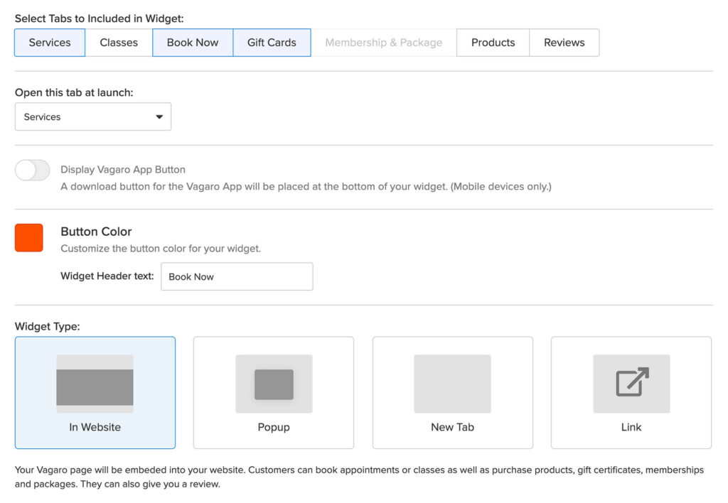

### 2.6.2 Fresha Online Booking

[Fresha](https://www.fresha.com/for-business/) provides you with an online booking page that you can link to from your website. The generic booking page you’re provided with looks good (see example image below). You cannot customize the design to reflect your branding.

You can also have your salon featured for bookings in the Fresha Marketplace.

### 2.6.3 Mangomint Online Booking

[Mangomint](https://www.mangomint.com/?utm_source=thesalonbusiness&utm_content=best-salon-software) allows you to customize an online booking page that you can link to from your website or social media. You can also choose to integrate the booking widget directly on your website and customize it with your logo and brand colours.

The website booking widget is super intuitive and clean and fits on every website as it nicely slides in from the side whenever someone clicks your “book now” button or link.

### 2.6.4 GlossGenius Online Booking

[GlossGenius](https://app.glossgenius.com/signup?utm_source=product_review&utm_medium=affiliates&utm_campaign=thesalonbusiness&utm_content=20211109_best-salon-software) allows you to create a beautiful-looking website in just a few clicks. The below image is from the example website I created using only the out-of-the-box material available inside GlossGenius. If you already have a website, they currently do not offer support for integrating a booking widget, but you’ll need to link out to your separate GlossGenius website to accept bookings. Appointments Online Booking

With [Square Appointments](https://thesalonbusiness.com/recommends/square-appointments/), you can create a booking website or generate 3 types of widgets to embed on your website.

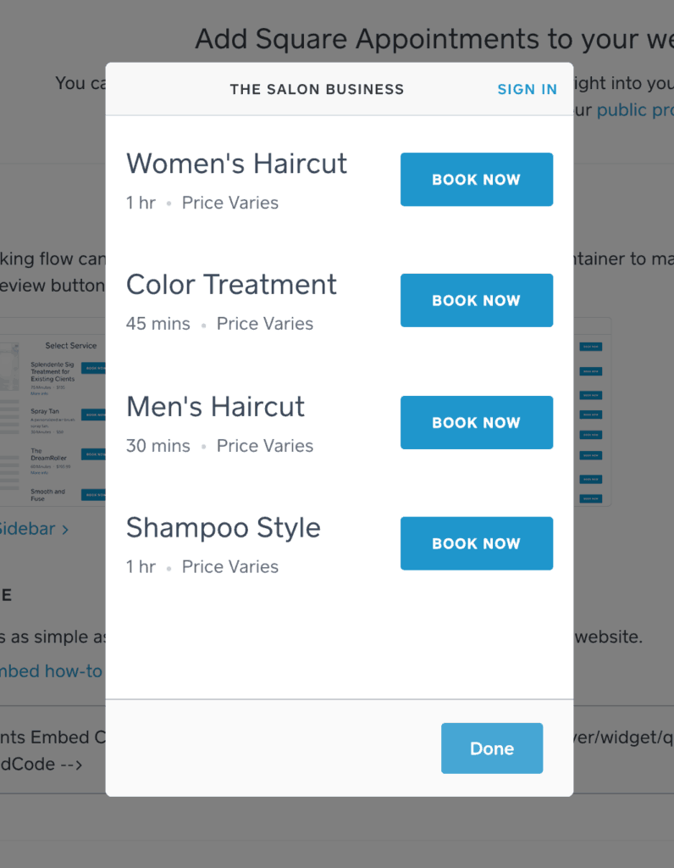

### 2.6.5 Salon Appointment Book

The salon appointment calendar works in an analogous way in all the salon software listed here. They all allow for drag-and-drop and have invested in making it as user-friendly as possible.

### 2.6.6 Vagaro Calendar

The [Vagaro](https://sales.vagaro.com/?utm_source=salonbusiness&utm_medium=partnership&utm_campaign=salonbusiness" \t "_blank) calendar is super intuitive and it’s easy to manage multiple calendars, colour code appointments, drag-and-drop to change.

They also offer an “agenda view” of the calendar. I love this format, especially on mobile, as it makes it extremely easy to see what’s coming up next without having to page through the full calendar.

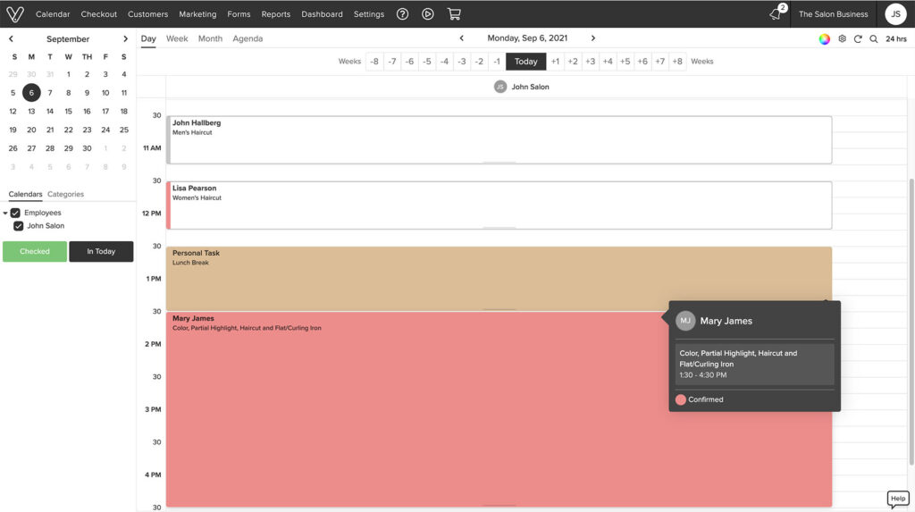2.6.7 Fresha Calendar

The Fresha calendar is super intuitive and easy to use. You can drag and drop appointments to change the time. Just hover over the appointment to see the full details. Quickly change the view from day view to week or month. Show multiple staff in the same view.

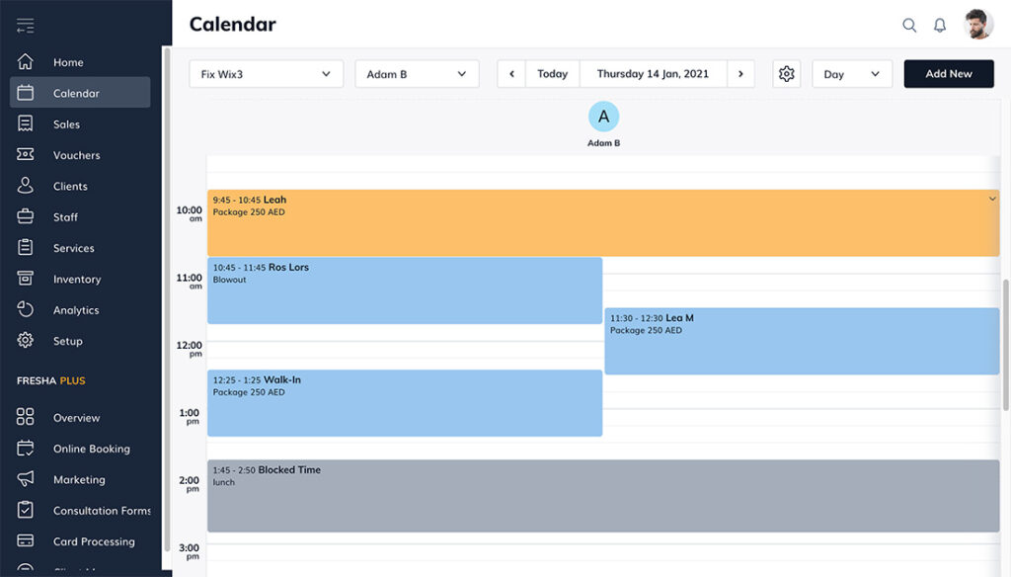

### 2.6.8 Mangomint Calendar

The [Mangomint](https://www.mangomint.com/?utm_source=thesalonbusiness&utm_content=best-salon-software" \t "_blank) appointment calendar is uncluttered and easy to use. Appointments are color-coded based on appointment status so you can get an overview briefly.

Drag and drop appointments to change time. Switch between day view and week view. Navigate between different members of staff or view them all at once in the day view. Click an appointment to check out the client.

### 2.6.9 GlossGenius Calendar

The [GlossGenius](https://app.glossgenius.com/signup?utm_source=product_review&utm_medium=affiliates&utm_campaign=thesalonbusiness&utm_content=20211109_best-salon-software" \t "_blank) calendar is intuitive and easy to use. Appointment colours are based on the service category booked. You can switch between day view, week view, and month view. You can switch between staff or show multiple staff calendars in the same view.

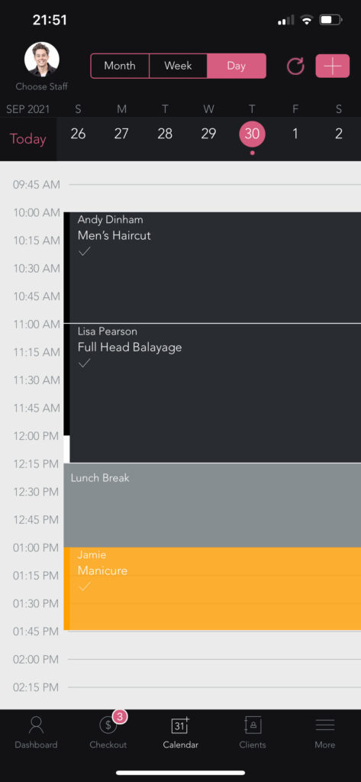

## 2.7 REFERENCES

<https://thesalonbusiness.com/best-salon-software/>

<https://sales.vagaro.com/>

<https://wellyx.com/client-management-software/>

<https://www.ogleschool.edu/blog/a-history-of-beauticians/>

<https://www.salonmanagementapp.com/>

<https://salonist.io/>

<https://www.rosysalonsoftware.com/>

<https://www.shedul.com/>

<https://wellyx.com/client-management-software/>

<https://www.thesmbguide.com/salon-management-software/>

<https://www.capterra.com/salon-software/>

<https://www.softwareadvice.com/salon/>

<https://www.miosalon.com/>

<https://www.capterra.com/salon-software/>

<https://biashara.co.ke/ads/salon-spa-booking-software-system-in-nairobi-kenya/>

<https://www.potentash.com/2020/10/14/beauty-technology-hair-saspacity-app/>

<https://www.ashleyskenya.com/book-appointment-online/>

<https://www.potentash.com/2020/10/14/beauty-technology-hair-saspacity-app/>

<https://www.thesmbguide.com/salon-management-software/>

<https://www.ashleyskenya.com/about-ashleys-kenya-limited/>

<https://www.techprevue.com/benefits-of-salon-software/>

<https://www.potentash.com/2020/10/14/beauty-technology-hair-saspacity-app/>

<http://www.digital.adcentsmedia.co.ke/digital-signage-solution-salon.php>

<https://www.miosalon.com/?code=MS0KFYVH&gclid=Cj0KCQjw0PWRBhDKARIsAPKHFGgqI0HqRZhKE1nd1zSpuvXC3W4yrq50dzlMNtVsQsHxSE3wQLnBeO4aAvXUEALw_wcB>

# CHAPTER 3: METHODOLOGY

## 3.0 RESEARCH METHODOLOGY AND DATA GATHERING

This is the way the problems to be solved while creating a new system will be identified and solved. In this case the internet will be of great use in providing the information on the existing systems and the problems being faced by the existing.

User based reviews on the existing platforms will also be useful in giving the general outlook of the systems and the level of satisfaction currently being given by the organizations to their users.

If need be, the owners of the systems will be contacted, and brief interviews conducted with an aim of gaining more clarity on how the systems are deployed and mode of functioning.

* Interviews

In this instance interviews were carried with a few experts and random clients as key respondents in order to find the type of services they require and how the experts got their jobs. This also enabled the evaluation of the payments received by each expert on a daily basis i.e., when they are presented with a job item.

### Review of existing systems

The existing applications were visited to figure out how they also worked and identify the major points of weakness as described by the users during the interviews. This also enabled the acquisition of first-hand experience when it came to getting opinion on the system.

### Online reviews by other sites

Reviews by other sites who are major stake holders in the market were taken into consideration as they gave a better outlook of the system due to experience in the current market and the vast nature of their comparison with even more precision involved.

## 3.1 SYSTEM DEVELOPMENT METHODOLOGY

The system will be developed using the Waterfall Project Management model. The model will contain the following steps:

1. **Requirement specifications**
2. **Analysis and System design**
3. **System coding**
4. **Testing and Debugging**
5. **Deployment and Maintenance**

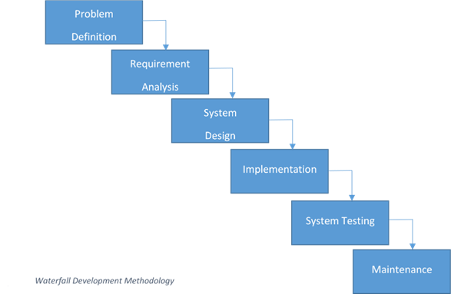

## 3.2 SYSTEM ANALYSIS

### 3.2.1 INTRODUCTION

System analysis refers to the process of examining the proposed system to understand its constraints, procedures, and functions. This involves gathering of information of how the system can be built to suit user needs and defining the system requirements. Prior to all the above a feasibility study should be carried out on the system.

### 3.2.2 FEASIBILITY STUDY

Feasibility is the process of measuring how the development of the proposed system will be beneficial or practical to the target group or users.

#### 3.2.2.1 Operational Feasibility

It is the measure of how well the solution will work and of how people feel about the proposed system.

The process of acquiring a job item by a client is usually a tiring one if the given client does not have the knowledge professional employment organizations. Similarly, the process of getting a client for an expert will be equally as straining. The proposed system should enable ease this situation by creating an environment where these two groups of individuals get to interact in a seamless manner.

#### 3.2.2.2 Technical Feasibility

It is the measure of the practicality of the proposed system about availability of technical resources and expertise.

The proposed system is a web based and uses emailing technology for communication between the system (organization), the clients and the experts. To achieve all these existing web-based technologies that are free to acquire and used will be utilized.

These technologies and resources include HTML, CSS, JavaScript, PHP and MYSQL as the scripting languages which will be used alongside software resources that include PHP-Storm editor, WAMP-Server local web hosting software and Google Chrome browser as the testing environment for the website during development.

#### 3.2.2.3 Schedule Feasibility

This is the measure of how reasonable the timeline for the proposed system is.

Twelve weeks is adequate to build the web application to completion. This is as there exists the technical expertise required for building the system.

#### 3.2.2.4 Economic Feasibility

This is the measure of the cost-effectiveness of the proposed system in terms of building the system and the return after the system is complete and functional.

The proposed system will be made by software tools which are open source hence free, and this makes the system building cost to be almost negligible. No further personnel services will be required during the development of the system making the whole process easy to carry out to completion without any further constrains.

## 3.3 Data analysis

### 3.3.1 Requirement Specifications

At this stage, knowledge about the existing systems from the interviews and reviews of the existing systems will be used. This will define their demerits and any other extra information that the users would like included in the proposed system.

### 3.3.2 Functional requirements

The system should be able to meet the following functional requirements:

1. Give users the ability to create accounts based on their interests i.e., clients or experts.
2. The system should allow clients to request for services
3. Allow the experts to post the services which they offer on the website

iv. The system should enable the notification of the laborers once there is a pending duty for them to attend to.

1. The system should enable the clients to make payments for their service and enable the payment of the experts upon the completion of each task.
2. The system should enable the cancellation of job orders by both the experts and the clients of need arises.
3. The system should enable the clients to be refunded in the instance of job cancellation unavailability of the experts on the said date of the delivery of the job order.
4. The system should enable the clients to keep track of all the services that they received and for the experts to also keep track of the clients that they have served.

### 3.3.3 Non-Functional Requirements

The system should be able to meet the following non-functional requirements:

1. **Usability:** The system should have a user interface that is easily usable by the clients.
2. **Security:** The system should not allow the clients to be able to access data in the system without registering first.
3. **Reliability:** The system should be accessible at any given time.
4. **Accuracy:** The system should be able to send emails to the specific client and experts and allow emails to also be sent to the organization for communication purposes.

### 3.3.4 System analysis models

This is a problem-solving method that involves looking at the wider system, breaking apart the parts and figuring how it works to achieve a particular goal as dictated by each portion of the system.

#### 3.3.4.1 Use Case diagram

Use case models give high level description of system by outlining the interaction between the users of the system and the system itself. This enables the modelling of the systems functionalities to the system requirements collected during the requirements stage of the system development life cycle. Use case diagrams use cases which are the various functionalities of the system and the actors who are the entities that interact with the various uses cases found in the system.

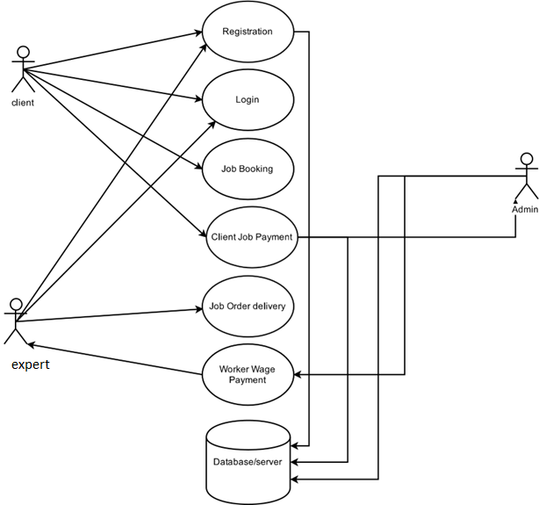

The table below shows the Use Case diagram description with respective actors.

|  |  |  |
| --- | --- | --- |
| **USE CASE** | **ACTOR** | **DESCRIPTION** |
| Register | Client  Experts | This enables both the client and the experts to both to sign-up for services in the system by handing in their relevant personal information. |
| Login | Client experts | This enables both the client and the experts to log into their respective accounts and carry out their respective activities in the system |
| Job Booking | Client | This enables the client to make a booking for an expert available in his area of locality |
| Job Order  Delivery | Experts | This informs the experts of a new job order and gives them instruct on how and where to deliver it |
| Client Job  Payment | Client | After receiving a match for the respective job order the clients is required to pay for the job order prior to receive the job order. |
| Experts Wage  Payment | Expert system  Admin | Once an order has been delivered the experts will get paid through the systems administrator. |

#### 3.3.4.2 Data flow Diagrams

**Context diagram**

The diagram below shows a level 0 Data flow diagram which gives an impression of the major flow of data items through the system as the entities interact with the system.

**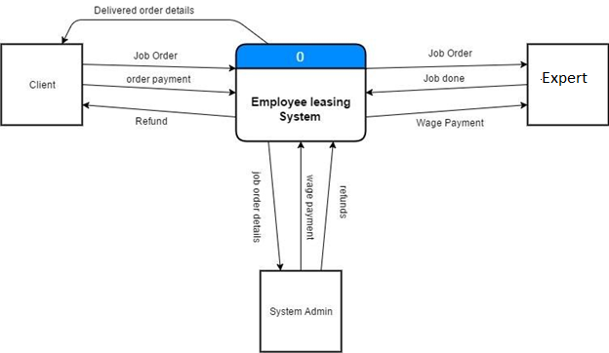**

**Level 0 Diagram**

This is dataflow diagram that explodes all the major processes of the system associated with all the data flows and data stores in the system as the users of the system get to interact with the system.

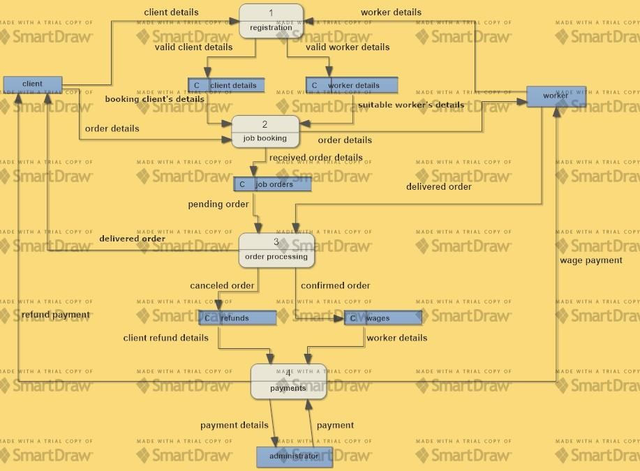

# CHAPTER 4: SYSTEM DESIGN

## 4.0 INTRODUCTION

System Design involves the conversion of the function models from System Analysis into models that represent the actual solution to the problem being solved.

From the functional requirements and non-functional requirements yielded from the analysis phase, designs for the system were made.

## 4.1 THE CONCEPTUAL MODEL

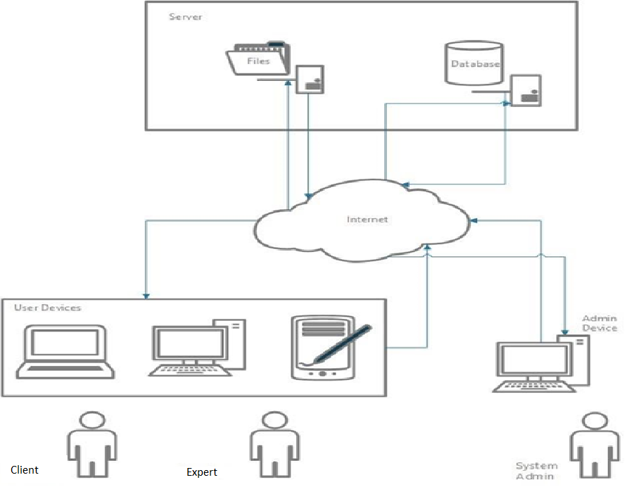

## 4.2 THE SYSTEM FLOW CHART

This are chart that represent the sequence of events that take place when the users of system get to interact with the system and carry out their various activities.

### 4.2.1 Client Flow Chart

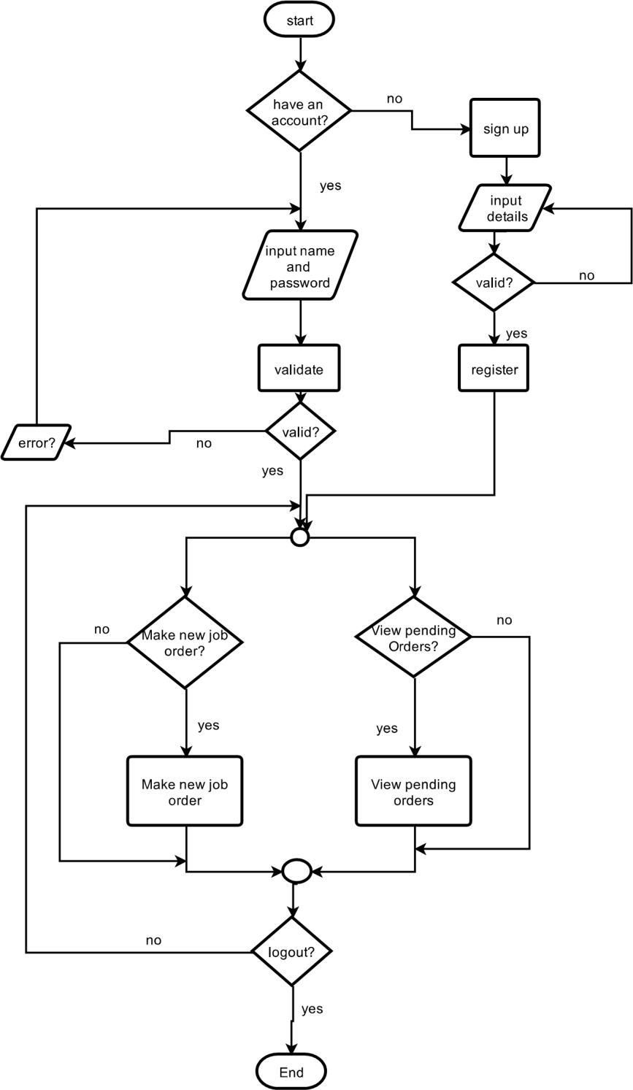

### 4.2.2 Experts flow chart

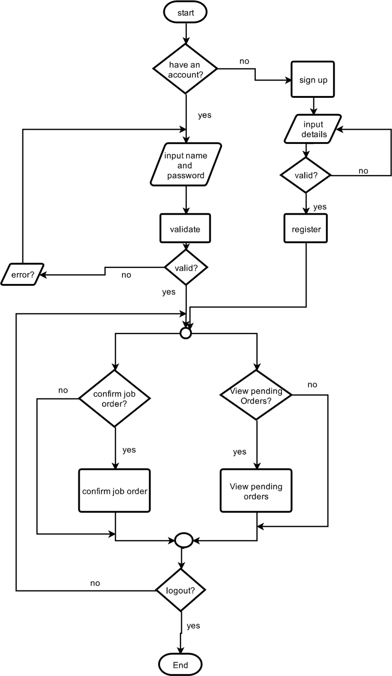

### 4.2.3 Database Design

#### 4.2.3.1 Entity relationship diagram

This is diagram that gives a diagrammatic representation of the system’s database. When the users of the system get to interact with the data entered or generated by the system is stored in the systems database with their relationship being as depicted in the figure below

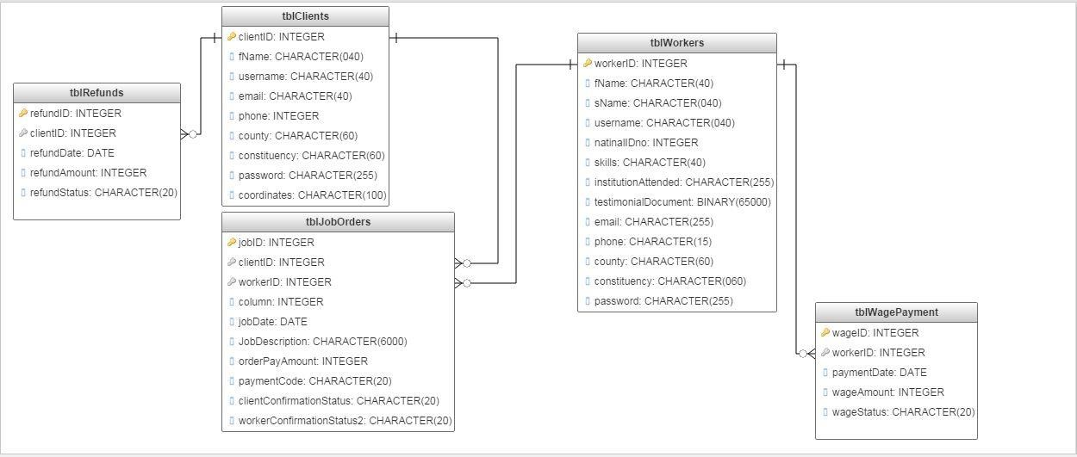

#### 4.2.3.2 Data dictionary – data elements tblClients

|  |  |  |  |  |
| --- | --- | --- | --- | --- |
| **Name** | **Description** | **Datatype** | **Length** | **Default value** |
| clientID | Contains a unique identifier for a client in the system | integer | 10 | none |
| fName | Contains the client’s first name | Variable character | 50 | none |
| sName | Contains the client’s last name | Variable character | 50 | none |
| username | Contains the client’s username as per the system | Variable character | 50 | none |
| email | Contains the client’s email address | Variable character | 50 | none |
| phone | Contains the client’s phone number | integer | 15 | none |
| county | Contains client’s county of residence | Variable character | 50 | none |
| constituency | Contains client’s constituency of residence | Variable character | 50 | none |
| coordinates | Contains the client’s exact location on the  map | Variable character | 100 | none |
| password | Contains the client’s secret account access key | Variable character | 255 | none |

#### 4.2.3.3 tblExperts

|  |  |  |  |  |
| --- | --- | --- | --- | --- |
| **Name** | **Description** | **Datatype** | **Length** | **Default value** |
| expertsID | Contains the expert’s unique identifier in the system | integer | 10 | none |
| fName | Contains the expert’s first name | Variable character | 50 | none |
| sName | Contains the expert’s last name | Variable character | 50 | none |
| username | Contains the expert’s username in the system | Variable character | 50 | none |
| natinalIDno | Contains the expert’s national identification card number | integer | 8 | none |
| skills | Contains the expert’s service skills | Variable character | 50 | none |
| InstitutionAttended | Contains the tertiary institution attended by the experts to obtain the skills | Variable character | 100 | None |
| testimonialDocument | Contains a document for the verification of the skills and institution provided by the experts in the system | binary |  | none |
| email | Contains the experts email address | Variable character | 100 | none |
| county | Contains the expert’s county of residence | Variable character | 50 | none |
| constituency | Contains the expert’s constituency of residence | Variable character | 50 | none |
| passWord | Contains the expert’s secret account access key | Variable character | 255 | none |

#### 4.2.3.4 **tblJobOrders**

|  |  |  |  |  |
| --- | --- | --- | --- | --- |
| **Name** | **Description** | **Datatype** | **Length** | **Default value** |
| jobID | Contains the unique identifier for a job order made by a client in the system | integer | 10 | none |
| clientID | Contains the unique identifier of the client who made a job booking in the system | integer | 10 | none |
| expertsID | Contains the unique identifier for the experts in the system assigned the task of serve the client who made a job booking | integer | 10 | none |
| jobDate | Contains the set date for the delivery of service for job booking made | date | 12 | none |
| jobDecription | Contains the brief description of the task to be performed by the experts as given by the client who made the job booking | Variable character | 6000 | none |
| orderPaymentAmount | Contains the amount payable for the job order made by the client | integer | 10 | none |
| paymentCode | Contains the M-pesa payment confirmation code for the payment made for the job booking by the client | Variable character | 10 | none |
| clientConfirmationStatus | Contains the client’s confirmation status on the delivery of service for the job booking made | Variable character | 15 | pending |
| expertsConfirmationStatus | Contains the expert’s confirmation status on the delivery of service for the job booking made | Variable character | 15 | pending |

#### 4.2.3.5 tblRefunds

|  |  |  |  |  |
| --- | --- | --- | --- | --- |
| **Name** | **Description** | **Datatype** | **Length** | **Default value** |
| resalon expertsD | Contains the unique identifier for the refund to be paid to the client upon cancelling of job order | integer | 10 | none |
| clientID | Contains the unique identifier of the client to be refunded | integer | 10 | none |
| refundDate | Contains the date on which the refund was given to the client | date | 12 | none |
| refundAmount | Contains the amount payable to the client as refund | integer | 10 | none |
| refundStatus | Contains the status of the refund payment | Variable character | 12 | pending |

#### 4.2.3.6 tblWagePayment

|  |  |  |  |  |
| --- | --- | --- | --- | --- |
| **Name** | **Description** | **Datatype** | **Length** | **Default value** |
| wageID | Contains the unique identifier for the wage payment to be made upon the successful completion of a job order | integer | 10 | none |
| expertsID | Contains the unique identifier of the experts to be given wage payment | integer | 10 | none |
| paymentDate | Contains the date on which the wage was given to the experts | date | 12 | none |
| wageAmount | Contains the amount payable to the experts as wage | integer | 10 | none |
| wageStatus | Contains the status of the wage payment | Variable character | 12 | pending |

## 4.3 System application design

### 4.3.1 Systems Homepage Framework

The diagram below shows the general design for the homepage and the successive pages making up the system. During the users (clients and experts) visit to the system they will get to interact with such an interface.

### 4.3.2 Systems User login page Framework

The diagram below shows the general design for the login page of the website. During the users (clients and experts) visit to the system they will get to interact with such an interface to log into their respective accounts.

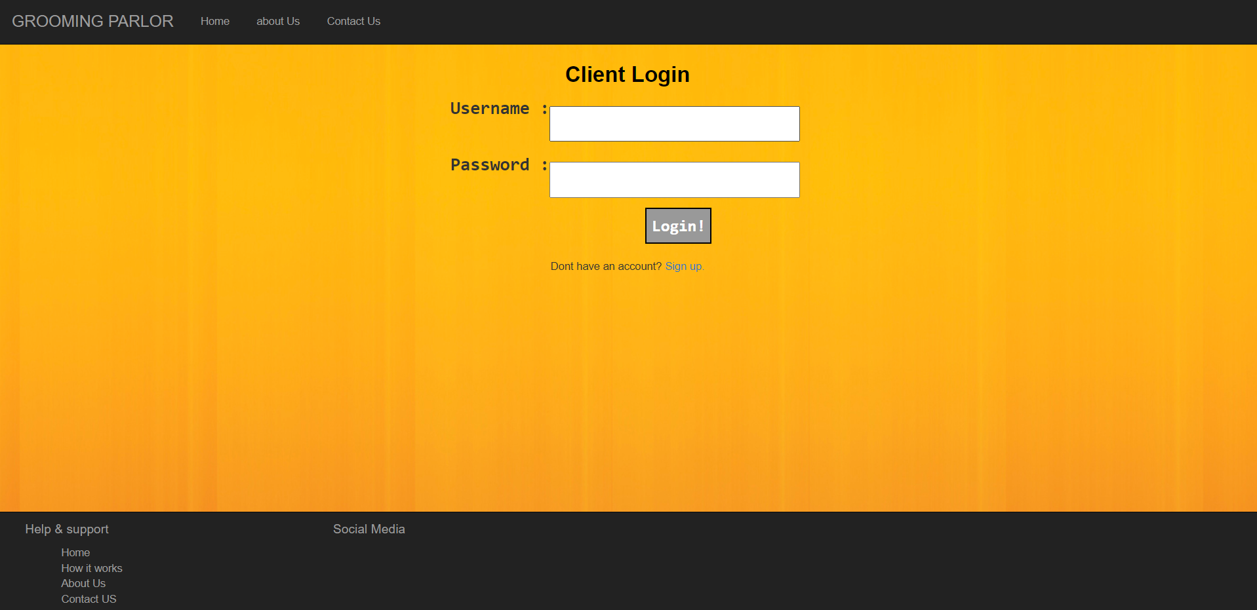

### 4.3.3 Systems Client job booking page Framework

The diagram below shows the general design for the client job booking page. During the client’s visit to the web site, he/she will get to interact with such an interface while making a new job booking for an expert in with the desired skills to match the job to be done.

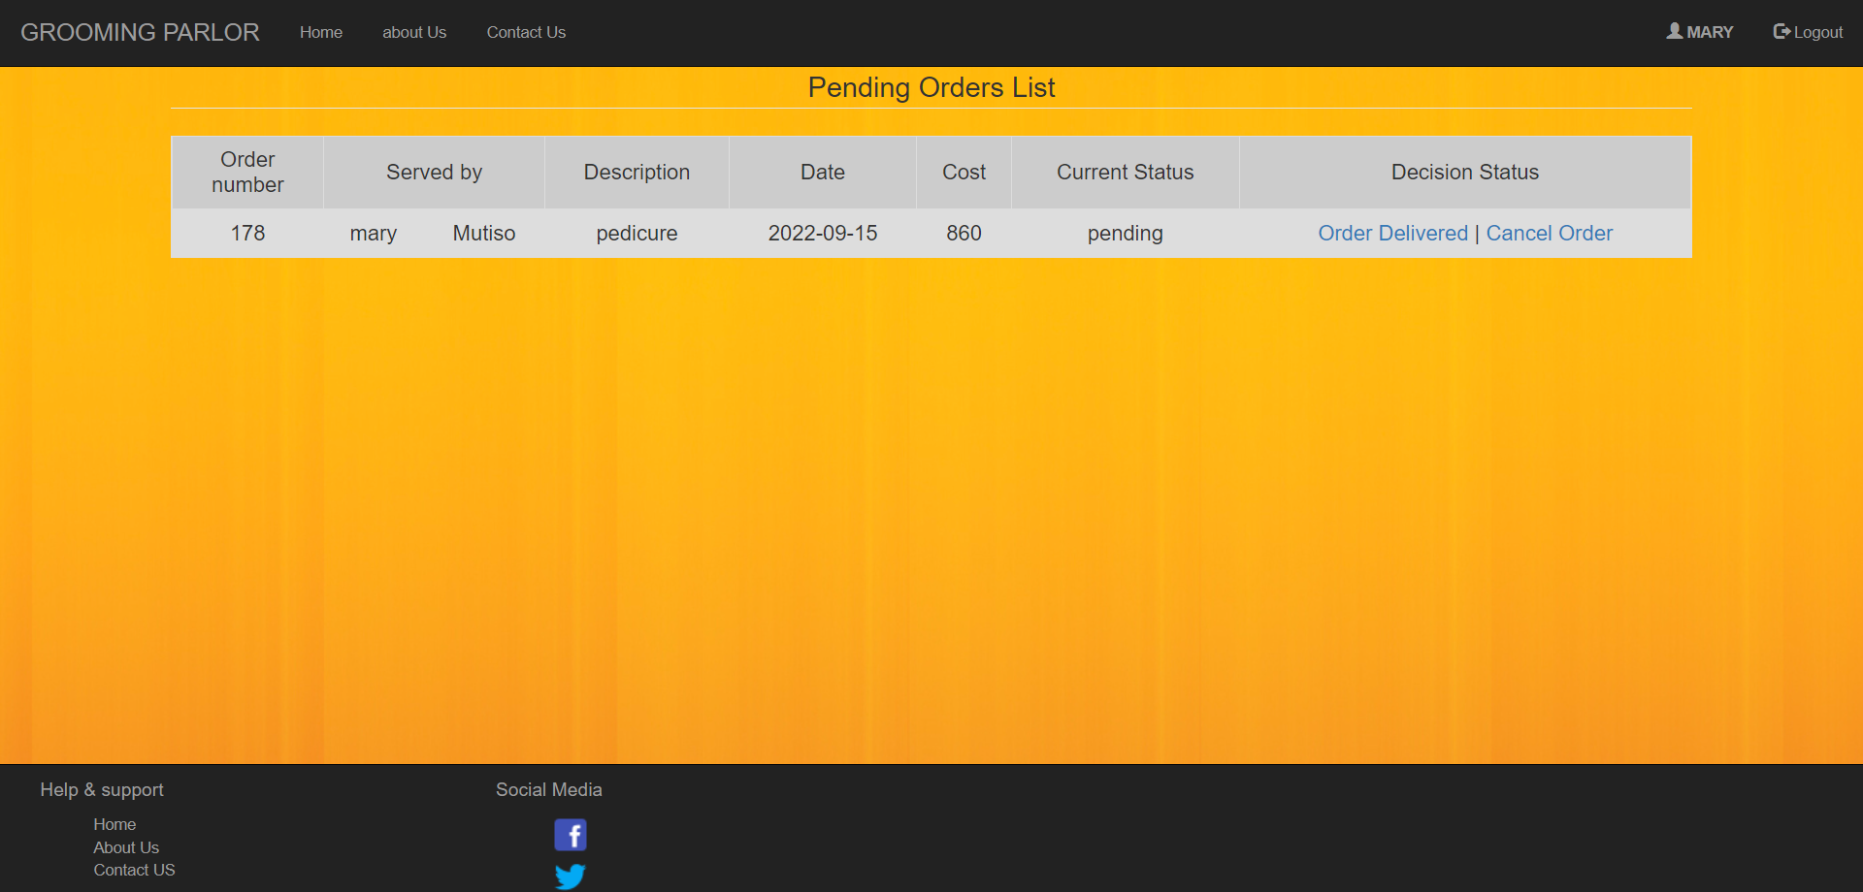

### 4.3.4 System Sitemap

This is a diagram showing the list of pages that are available in a website to which users can access as they interact with the system. This diagram shows how each page is and it contains are related to other pages on the website and their respective components. The diagram below shows sitemap of the Salon experts’ website.

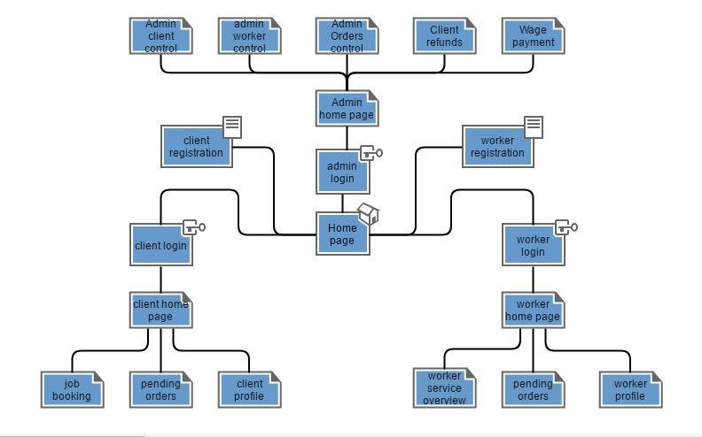

# CHAPTER 5: IMPLEMENTATION

## 5.0 IMPLEMENTATION

## 5.1 Resources required

The system will be developed using the following hardware and software resources

### 5.1.1 Hardware resources

The computer that will be used to develop the will have to meet the following requirements:

1. 4 Gigabytes of RAM.
2. 300 Gigabytes of storage space.
3. 1 Gigabytes of dedicated graphics card memory.

iv. 2 GHz CPU processing speed.

.

### 5.1.2 Software resources

The following software tools and scripting languages will be used to develop the system to completion:

1. **WAMP server** – this will be localhost software for the system
2. **PHP storm** – this is the integrated development environment that supports HTML, CSS, JavaScript and PHP scripting languages.
3. **MySQL** – this will be software where the system’s database will exist.

iv. **Google Chrome browser** – this will be the testing browser for the system.

1. **Windows 10 operating system** – the operating system upon which the system will be deployed.
2. **HTML and CSS** – languages for the front-end design of the system’s webpages
3. **JavaScript** – language for enhancing interactivity and data entry validation on the webpages.
4. **PHP** – the language for connecting the webpages to the database of the system.
5. **MySQL** – the language implementing the system’s database.
6. **Google maps API** – application programming interface for aiding the navigation capabilities during the communication of the systems users (experts).

# CHAPTER 6: SYSTEM TESTING

## 6.0. System testing and debugging

## 6.1 System testing

After completing the development of the system testing will be done to ensure that the system functions as expected. The testing will be done in the following terms:

1. **Unit testing** – This will involve testing each module in the system for any error during performance.
2. **Integration testing** – this will involve the testing of how different in the system work when combined to work on a given task in the system.
3. **Data validation and exception testing** – this will do by entering both correct and incorrect data input into the system to see how the different modules will process data even in exceptional situations.
4. **System testing** – when all the above stages of testing are completed the whole of the system will be tested before being deployed.

6.2 Test cases

Test cases identify and communicate the conditions that will be implemented in test and are necessary to verify successful and acceptable implementation of the system’s requirements.

|  |  |  |  |  |  |
| --- | --- | --- | --- | --- | --- |
| **Test case** | **Module** | **Description** | **input** | **Expected results** | **Actual output** |
| 1 | Registration | This enables both the client and the experts to both to signup for services in the system by handing in their relevant personal information. | Enter valid personal details. | Success message and redirection to login page. | Success message and redirection to login page. |
| Enter invalid personal details. | Error message displayed and prompt re-entry of personal details. | Error message displayed and prompt re-entry of personal details. |
| 2 | Login | This enables both the client and the experts to log into their respective  accounts and carry out their respective activities in the system | Enter valid login details. | Success message and redirection to account home page. | Success message and redirection to account home page. |
| Enter invalid login details. | Error message displayed with prompt to re-enter login details. | Error message displayed with prompt to re-enter login details. |
| 3 | Job booking | This enables the client to make a booking for an expert available in his area of locality fitting the required job requirement. | Enter valid booking details. | Success message with update of pending order list and receipt of acknowledgement email. | Success message with update of pending order list and receipt of acknowledgement email. |
| Enter invalid booking details. | Error message displayed with prompt to re-enter the invalid booking detail. | Error message displayed with prompt to re-enter the invalid booking detail. |
| 4 | Job order  cancellation | This enables the client to cancel a job order prior to the set date of order delivery if the need arises.  This also | Job order  cancellation before the set date for the job order delivery. | Success message displayed with update of pending job orders list and acknowledgement email for the job cancellation. | Success message displayed with update of pending job orders list and acknowledgement email for the job cancellation. |
|  |  | enables refund payment to the  client | Job order  cancellation on the set date for the job order delivery. | Error message  displayed preventing job order cancellation by client. | Error message  displayed preventing job order cancellation by client. |
|  |  |  |

## 6.3 System deployment and Maintenance

After completion of the testing and debugging phase of the system development life cycle, the system will then be deployed to a few users for testing for a given period to get the overall response on the system from users. The feedback from the users will then be used to tweak the system further to fit the overall user liking.

# CHAPTER 7: CONCLUSION

## 7.0 Achievements

The successful completion of the project produced a working system based on the previously listed design specification and conceptual model. The working model was able to meet the following user requirements:

1. The system gave users the ability to create accounts based on their interests i.e., clients or experts
2. The system enabled clients to request for services from the experts in the system.
3. The system allowed the experts to post the services which they offer on the website.

iv. The system enabled the notification of the experts once there is a pending duty for them to attend to.

1. The system enabled the clients to make payments for their service and enabled the payment of the experts upon the completion of each domestic task.
2. The system enabled the cancellation of job orders by both the experts and the clients of need arises.
3. The system enabled the clients to be refunded in case of a job cancellation due to unavailability of the experts on the said date of the delivery of the job order.
4. The system enabled the clients to keep track of all the services that they received and for the experts to also keep track of the clients that they had served.

## 7.1 Constraints

Despite the successful completion of the project and the production of a working system a few challenges were met, and this hindered the full implementation of some functionalities of the system. The challenges include:

• The acquisition of an M-pesa pay bill account number was hindered by the inflated cost hence the payment process in the system had to be simulated through the system’s database.

## 7.2 Recommendation

This web application can further be reviewed further and modified to incorporate M-pesa and ratings of services by the employees.

## 7.3 Conclusion

The main aim of this project was to develop a web-based system that would allow the clients to be able to book experts and assure that the clients obtain standard services. This project has successfully been completed and will go a long way changing the current operations regarding the experts and clients.

## 7.4 References

# 

Anon., 2016. *The Entrepreneur.* [Online]

Available at: https://www.entrepreneur.com/encyclopedia/leased-employees

Kenya, C. A. o., 2017. *94 - News.* [Online]

Available at: http://www.ca.go.ke/index.php/what-we-do/94-news/366-kenya-s-mobile-penetrationhits-88-percent

kenya, J., 2017.

*Nani.co.ke.* [Online] Available at: http://www.nani.co.ke/

## 7.5 Appendix A: Sample Code

The appendix illustrates shows the main PHP code that is used for the allocation of experts to the client upon application

Booking.php: <?php include('../html/check.php'); require '../PHPMailer/PHPMailerAutoload.php'; if (isset($\_POST['submit'])){

$curruser = $\_SESSION['username'];

$expertskills = trim($\_POST["expertskills"]);

$jobDescription = trim($\_POST["jobDescription"]);

$jobDate = trim($\_POST["date"]);

$totalCost = trim($\_POST["totalCost"]);

$ses\_sql = mysqli\_query($db,"SELECT clientID, fName, sName, email, phone,

county, constituency, latitude, longitude FROM myclientinfo WHERE username='$curruser' ");

$row=mysqli\_fetch\_array($ses\_sql,MYSQLI\_ASSOC);

$clientID=$row['clientID'];

$clientFname=$row['fName'];

$clientSname=$row['sName'];

$clientEmail=$row['email'];

$clientPhone=$row['phone'];

$county=$row['county'];

$constituency=$row['constituency'];

$clientLocLatitude=$row['latitude'];

$clientLocLongitude=$row['longitude'];

$sql = "SELECT expertsID, fName, sName, username, email, phone FROM myexpertsinfo WHERE expertskills='$expertskills' AND (county = '$county' OR constituency='$constituency') ORDER BY jobCount ASC LIMIT 1"

$result= mysqli\_query($db,$sql); $row= mysqli\_fetch\_assoc($result); if(mysqli\_num\_rows($result) > 0)

{

$expertsID=$row['expertsID'];

$expertsFname=$row['fName'];

$expertsname=$row['sName'];

$expertsUsername=$row['username'];

$expertsEmail=$row['email'];

$expertsPhone=$row['phone'];

$sql = "INSERT INTO tbljobOrders (clientID, clientUsername,

clientFname, clientSname, clientEmail, expertsID,expertsUsername, expertsFname, expertsname, expertsEmail, jobDescription, jobDate,totalCost, clientLocLatitude, clientLocLongitude, clientPhone, expertsPhone)

VALUES

('$clientID','$curruser','$clientFname','$clientSname','$clientEmail','$expertsID','$expertsUsername','$wor kerFname','$expertsname','$expertsEmail','$jobDescription',

'$jobDate','$totalCost','$clientLocLatitude','$clientLocLongitude','$clientPhone','$expertsPhone')";

if (mysqli\_query($db,$sql) == TRUE){ echo "New record created successfully";

}else {

echo "Error: " . $sql . "<br>" . $db->error;

}

$sql = "Update myexpertsinfo set jobCount = jobCount + 1 where

expertsID = '$expertsID'";

|  |  |  |  |
| --- | --- | --- | --- |
|  |  | mysqli\_query($db,$sql); | |
|  |  | header("location: mailer.php"); | |
|  |  | }else{ | |
|  |  |  | $mail = new PHPMailer; |
| output |  |  | //$mail->SMTPDebug = 3; // Enable verbose debug |
|  |  |  | $mail->isSMTP(); // Set mailer to use SMTP |
| servers |  |  | $mail->Host = 'smtp.gmail.com'; // Specify main and backup SMTP |
| authentication |  |  | $mail->SMTPAuth = true; // Enable SMTP |
| username |  |  | $mail->Username = 'salon expertssfixem@gmail.com'; // SMTP |
|  |  |  | $mail->Password = 'experts2017'; // SMTP password |
|  |  |  | $mail->SMTPSecure = 'ssl'; // Enable TLS encryption, |
| `ssl` also accepted | |
|  | |  | $mail->Port = 465; // TCP port to connect to |
|  | |  | $mail->setFrom('salon expertssfixem@gmail.com', 'The Salon expertss'); |
|  | |  | $mail->addAddress($clientEmail); // Add a recipient |
|  | |  | $mail->Subject = 'No match found'; |
|  | |  | $mail->Body = "<br>Dear $clientFname $clientSname this is to notify |

you no match could be found for your job order. We are working increasing our experts database so to deal with such issues in the future. kindly check in later to see if we might be having any free experts.<br>Feel free to contact us with any complaints and quetsions.<br>Regards<br>

The Salon expertss.";

$mail->AltBody = 'This is the body in plain text for non-HTML mail clients';

if(!$mail->send()) {

echo 'Message could not be sent.'; echo 'Mailer Error: ' . $mail->ErrorInfo;

} else {

header("location: ../html/home.php");

}

}

}

?>